# Blockchain Technology

# Mini Project

# UI of Website

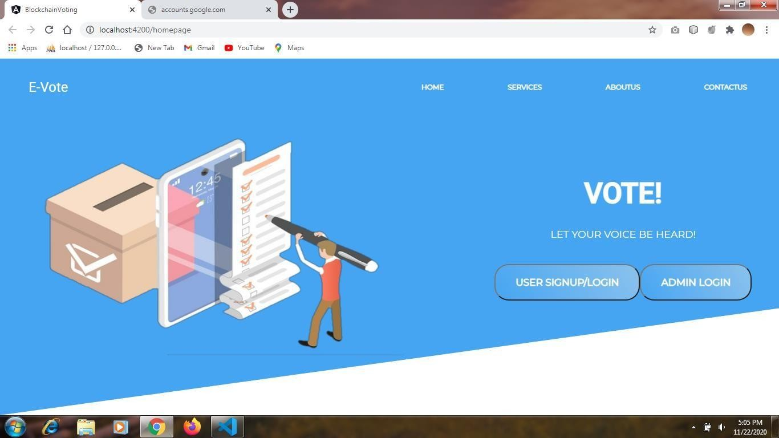

Fig.4.1 Homepage

* + - The homepage consists of 2 options –

1. First option is for admin login
2. Second option is for user signup/login

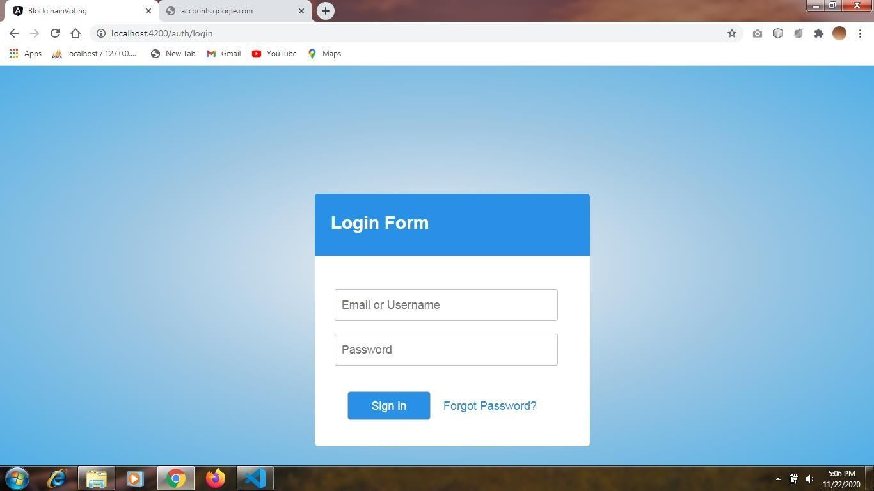

Fig.4.2 Admin Login

* + - This is the login page for admin.

After admin is logged in he is directed to the dashboard

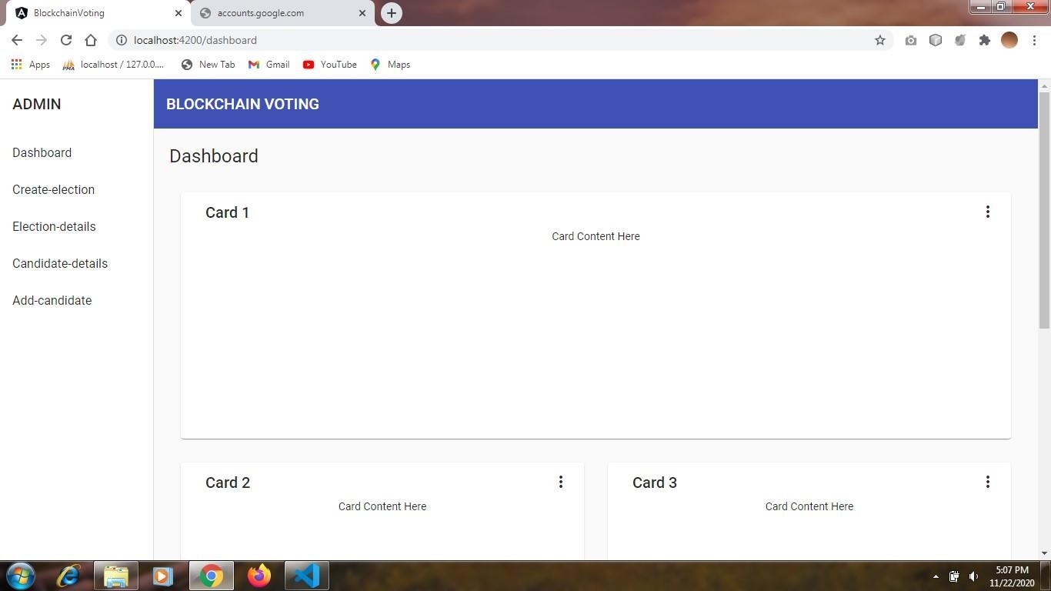

Fig.4.3 Admin Dashboard

* + - The dashboard will contain various charts to display information such as number of parties, number of voters etc.

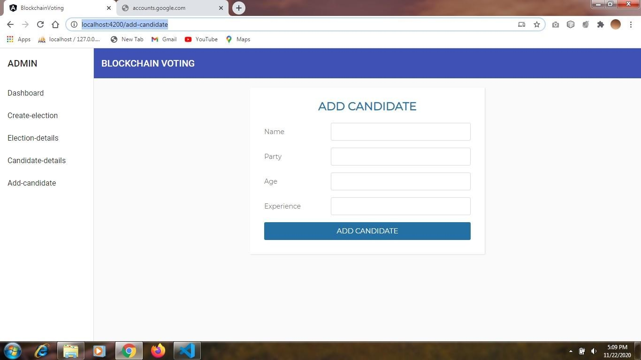

Fig.4.4 Add Candidate Page

* + - In this feature of admin, he can add candidates who are standing in the election.
    - After candidate is added it will be displayed on the user side.

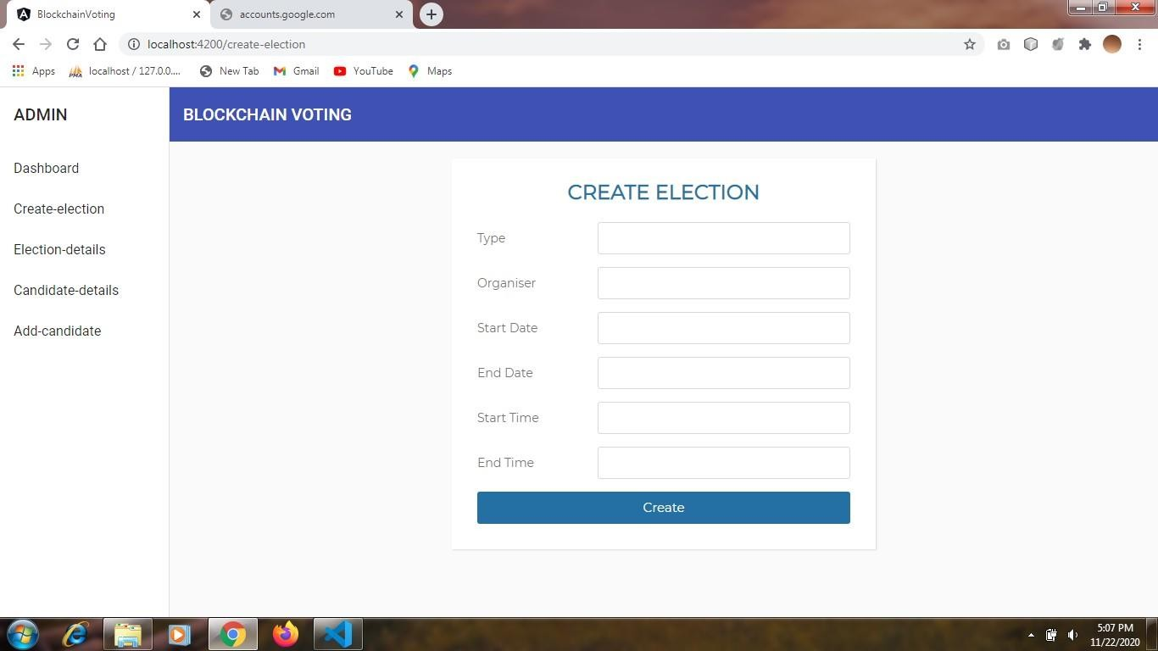

Fig.4.5 Create Election Page

* + - This feature of admin will allow him to create election.
    - A user can cast his vote only after the election is created by admin.
    - A user can cast vote between the start date and end date.

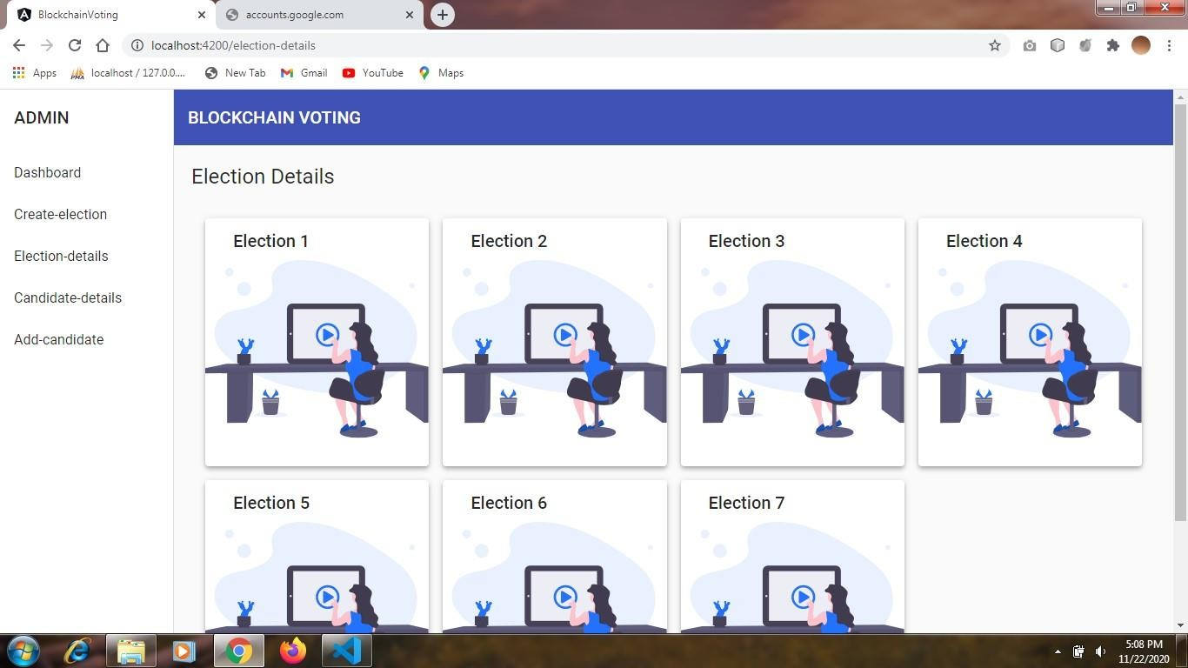

Fig.4.6 Candidate Details

In candidate details all the candidates added by admin will be displayed. Admin can update the candidate details if incase a wrong entry is done.

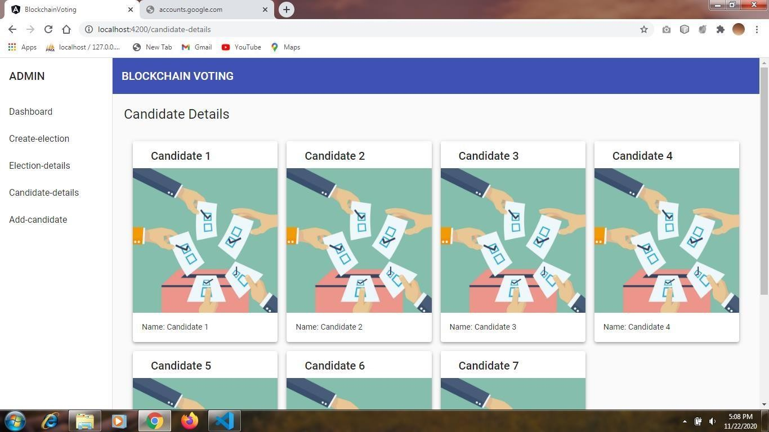

Fig.4.7 Election details

* + - In this section admin can update election details such as start date, end date etc.

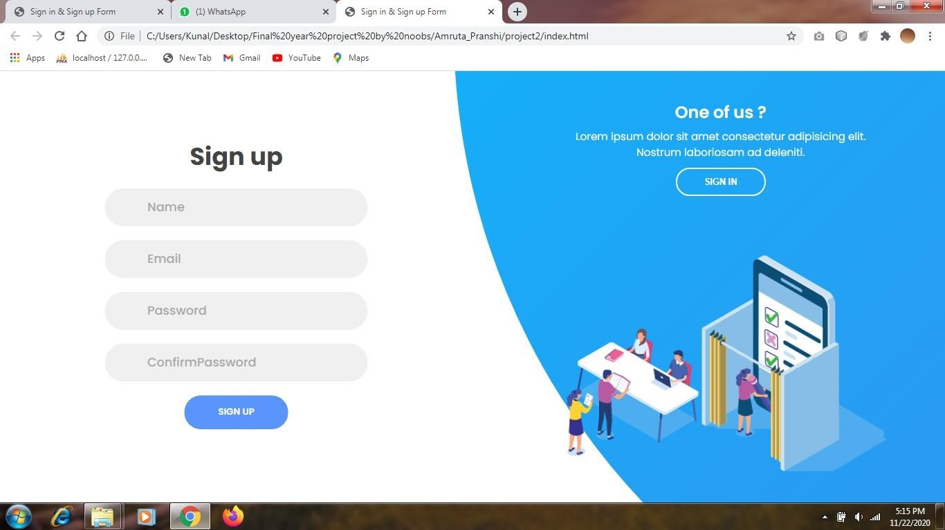

Fig.4.8 User Sign up

* + - User will have to sign up before login.
    - This is the signup page for the user.

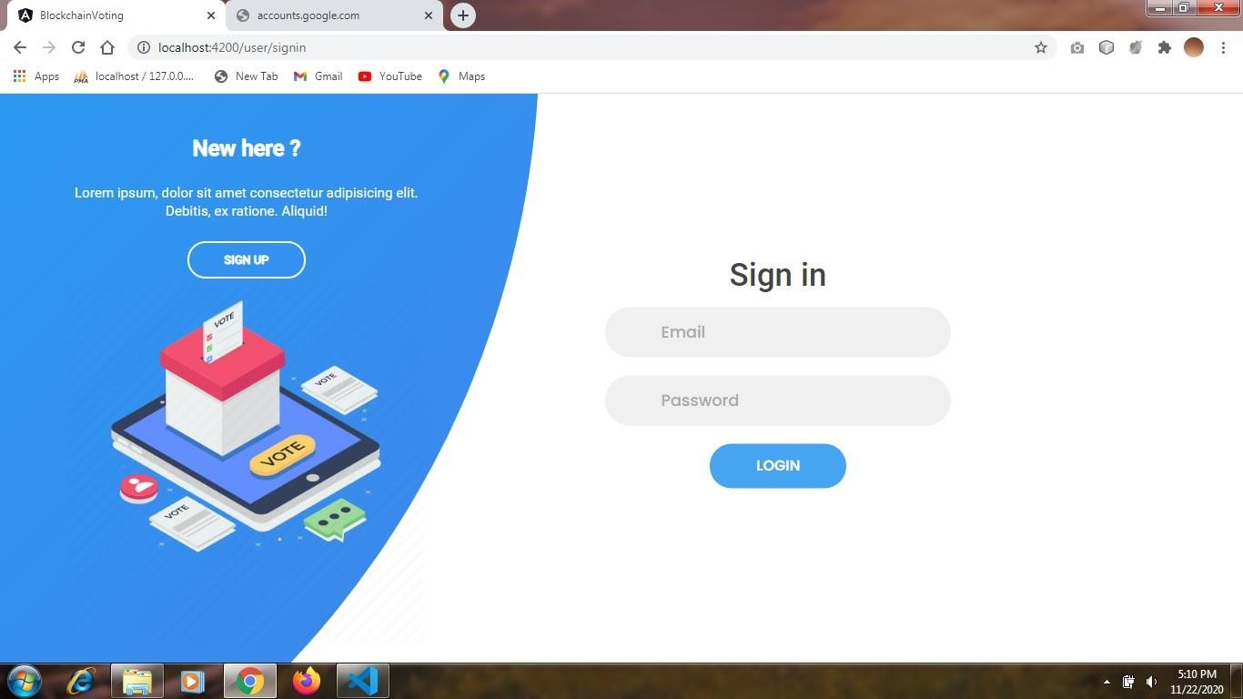

Fig.4.9 User Sign in

* + - If user chooses user sign in option on homepage he will be directed to this page.
    - After login he will be directed to user dashboard.

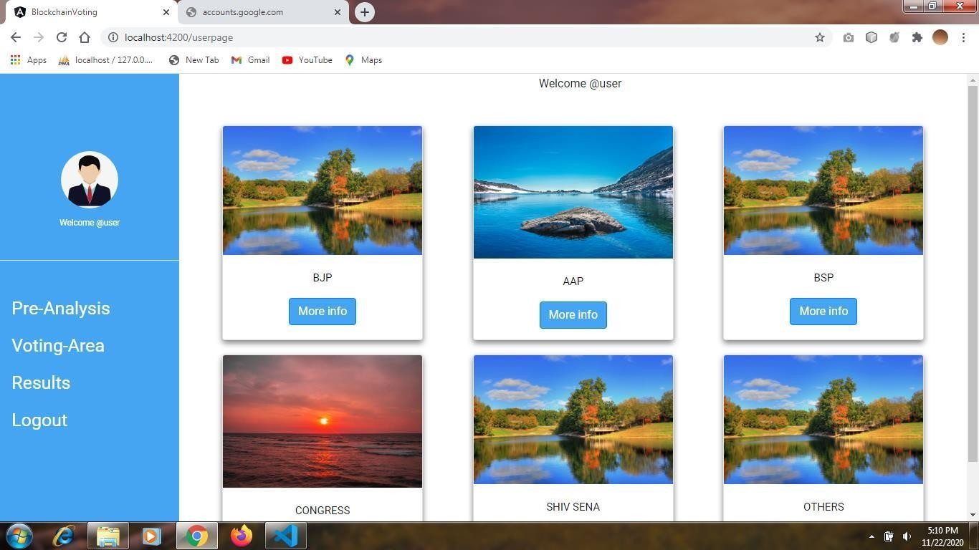

Fig.4.10 User Dashboard

* + - The user dashboard contains information about parties and their candidates.
    - A user can see all the information about candidate.

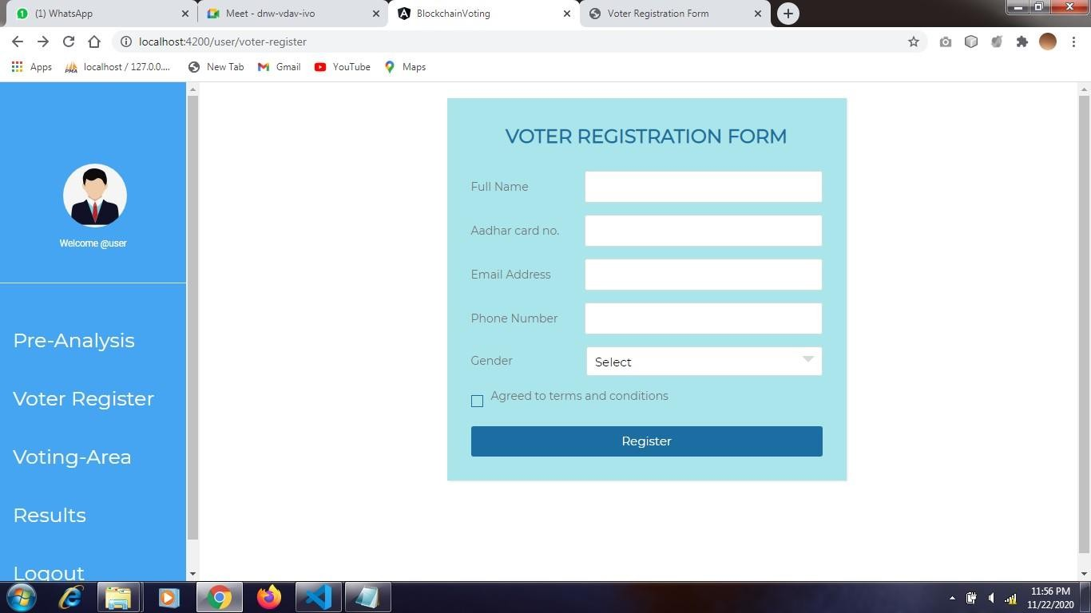

Fig.4.11 Voter Registration form

In this section first user will have to register himself only then he will be able to cast his vote.

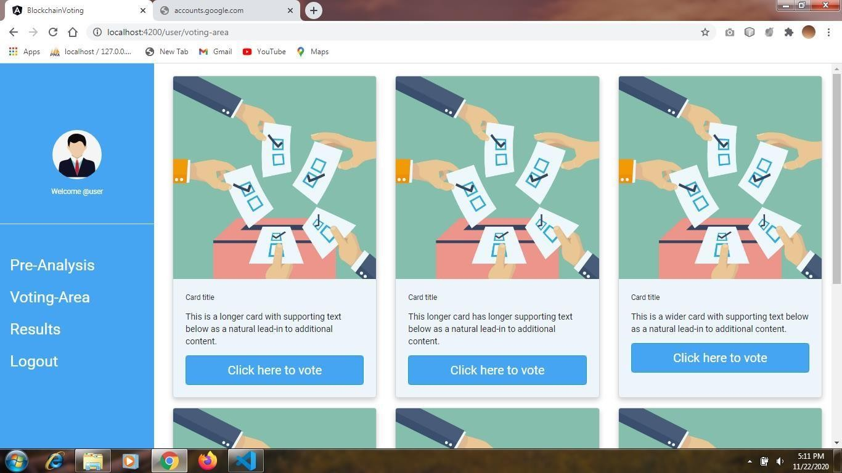

Fig.4.12 Vote Casting Page

After user is registered, then only he will be directed to this page and then he can cast his vote.